The Pauline Elizabeth Hopkins Society

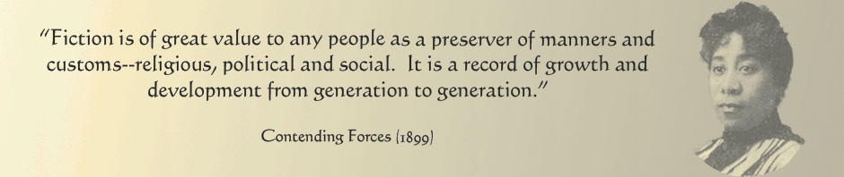

Pauline Elizabeth Hopkins Memorial
High School Scholarship and Creative Writing Awards
2019
The Pauline Hopkins Society (http://www.paulinehopkinssociety.org) is pleased to welcome submission for the third bi-annual Pauline Hopkins Memorial High-school Scholarship in honor of the society’s ten-year anniversary. The award is intended to commemorate the life and work of Boston and Cambridge-based writer Pauline Elizabeth Hopkins (1859-1930), who lived and worked in the area in the late 19th and early 20th centuries. A dynamic polymath and extremely prolific writer, Hopkins first came to prominence when she won an award for an essay she wrote as a teenager on the “Evils of Intemperance and Their Social Remedy.” She went on to write several popular plays and novels, and was a writer and the editor-in-chief of The Coloured American Magazine from its creation in 1900 to 1904, when the magazine moved its offices to New York.

This year, there will be two awards granted of $200 cash scholarships that will be presented to college-bound African American female students of the Boston and Cambridge, MA Public Schools systems who have submitted the best essay and best creative piece that incapsulates the topics of social justice and/or the genre and writing style employed by Hopkins in her novels, short stories, periodicals, dramas, and so forth.

Interested candidates can submit an essay/creative piece between 1000 and 2500 words on any aspect of social justice or Hopkins’ writing style, broadly conceived. Only one essay and one creative writing entry is permitted per student. Essays and creative pieces must be solely the work of the entrant.

How to Enter:
Deadline: Essays must be submitted by March 15, 2019 via email to: PHShsaward@gmail.com

Eligibility: Applicant must be an African American female currently enrolled as a senior or junior of a Cambridge or Boston Public high school, or a recent graduate (within two years). Applicants cannot be currently enrolled as a full-time student in a college or university.

Evaluation Criteria: Essays and creative pieces will be judged on both style, originality, and content. For essays, judges will look for writing that is lively, clear, articulate, and logically organized. For creative pieces, judges will look for work that is unique, substantive in purpose or meaning, and reflective of Hopkins’ writing style. Winning pieces must demonstrate an outstanding grasp of the significance of social justice—a topic of central and lifelong interest for Hopkins—and how Hopkins incorporated this crucial subject within her writing. (http://www.paulinehopkinssociety.org).
Participants may submit a single entry for both award categories, but can only win an award in one category.

The award will be presented during a special ceremony commemorating Hopkins and her work in Boston during the American Literature Association annual conference in May 2019.

