The Pauline Hopkins Society

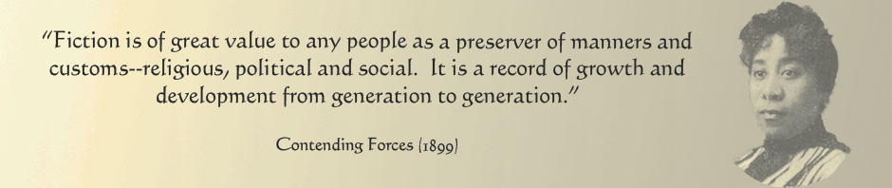

Scholarship Award
2019
The Pauline Hopkins Society (http://www.paulinehopkinssociety.org) is pleased to announce its third bi-annual competition and tenth-anniversary celebration. The society will award the best scholarly publication – book, essay, or book chapter on Pauline Elizabeth Hopkins published between January 1, 2015 and December 31, 2018. If you have published an essay or chapter that discusses Hopkins and/or her work, we invite you to consider entering before the March 15, 2019 deadline.

Because entries will be judged through a system of blind reviewing we recommend that any self-citation, either in the body or in notes, be reworked to the third person.

How to Enter:
Essays should be double-spaced throughout, with your name appearing only on the cover sheet, along with your institutional mailing address and e-mail address.

Please send essay as a pdf email attachment by March 15, 2019 to: PHSscholaraward@gmail.com

The award of a $100 cash prize will be presented during a special ceremony commemorating Hopkins and her work in Boston during the American Literature Association annual conference in May 2019.

